Ms. Fortunato’s Class Supply List

These are the requested items for this school year. Most items have been donated.

These items get used up quickly so please consider donating more than the requested amount below.

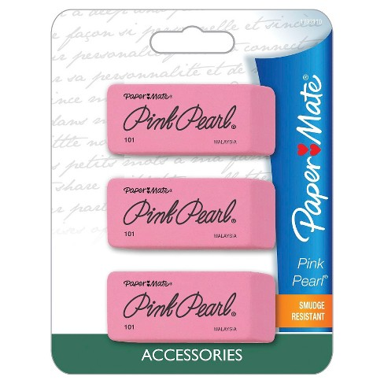
Container of Clorox wipes
Bottle of Hand Sanitizer
Package of 24 Crayola Crayons
3 Boxes of Tissues
Large pink erasers ( like these…..)
Dry Erase Markers

Items not permitted:
Binders
Pencil sharpeners without a cap
Large pencil cases or boxes (these are noisy, spill often and don’t fit in desks)
Pencil eraser toppers (kids throw these!)
Foil wrapped/ Designer/ Fancy pencils

Your child will be using headsets in the classroom. When many students are sharing headsets, this can be a health concern. We are asking that your child bring in computer headsets that we will keep just for him/her.

Throughout the year, we throw parties for holidays, birthdays, and various other celebrations. Could you please consider donating one of the following based on your last name?

A-D Ziplock Bags- sandwich size I-M Ziplock Bags- snack size
E- H plastic cups N-Z paper towels/ Napkins

